YOUR TA’S NAME:

Lecture Worksheet
Thursday 10/29/2020

MAIN POINTS OF LECTURE

- Even if there is no association between two discrete variables X and Y in the population, we may observe an association between X and Y in sample data because of random error or sampling variability
- How can we tell whether the association observed between discrete variables X and Y in sample data is strong enough to rule out the hypothesis that in the population X and Y are statistically independent (or not associated with one another)?

  - We begin with the null hypothesis that there is no association between X and Y in the population … that is, we assume “statistical independence”
  - We then compute the cell frequencies that we would expect to observe under the null hypothesis and compare them to the actually observed cell frequencies
  - The χ² test statistic quantifies the degree to which the observed frequencies differ from the frequencies that we would expect to observe under the null hypothesis
$$χ^{2}=Sum of \frac{{\left(Expected-Observed\right)}^{2}}{Expected}=\sum_{i=1}^{R}{\sum_{j=1}^{C}{\frac{{\left({\hat{f}}_{ij}-f_{ij}\right)}^{2}}{{\hat{f}}_{ij}}}}$$
where R is the number of rows in the crosstable; C is the number of columns in the crosstable; “observed” or f_{ij} is the number of cases observed in the cell in row i and column j; and “expected” or ${\hat{f}}_{ij}$ is the number of cases we’d expect to see in that cell if the null hypothesis is true.
- Here, the “expected” cell counts or ${\hat{f}}_{ij}$ equal:
$${\hat{f}}_{ij}=\frac{\left(f_{i•}\right)\left(f_{•j}\right)}{N}$$
where f_{i•} is the number of cases in row i, f_{•j} is the number of cases in column j, and N is the sample size
- For hypothesis tests involving χ², degrees of freedom or df=(R—1)(C—1) where R=number of rows in the crosstable and C=number of columns in the crosstable

- When X and Y are ordinal, gamma describes the association between them
  - Gamma too complex to calculate by hand (in this class)
  - Gamma = -1 = a perfect negative association (as X goes up, Y goes down)
  - Gamma = +1 = a perfect positive association (as X goes up, Y goes up)
  - Gamma = 0 = no association (as X goes up, nothing happens to Y)

- When X and Y discrete and have only two categories, gamma, relative risk, and odds ratios describe the relationship between them. They each provide different sorts of information

  - Each requires referring to the 4 cells of the 2-by-2 table as follows:
X=1 X=2
Y=2 a b
Y=1 c d

  - Relative Risk
    - Express the change in the risk of being in a particular category of the “dependent” (Y) variable that result from changing categories of the “independent” (X) variable
    - RR <1 means that the risk that Y=2 is reduced when you move from X=1 to X=2
    - RR = 1 means that the risk that Y=2 is unchanged when you move from X=1 to X=2
    - RR >1 means that the risk that Y=2 is increased when you move from X=1 to X=2

  - Odds Ratio
    - Express the change in the odds of being in a particular category of the “dependent” (Y) variable that result from changing categories of the “independent” (X) variable
    - OR <1 means that the odds that Y=2 is reduced when you move from X=1 to X=2
    - OR = 1 means that the odds that Y=2 is unchanged when you move from X=1 to X=2
    - OR > 1 means that the odds that Y=2 is increased when you move from X=1 to X=2

- Associations between X and Y that are statistically significant may not necessarily be large or important; always necessary to assess the strength and direction of the association

QUESTIONS

- [From the recorded lecture] What is the critical value of χ² when α=0.05 and…
…the table has 2 rows and 3 columns?

…the table has 5 rows and 3 columns?

- [From the recorded lecture] What is the critical value of χ² when α=0.01 and…
…the table has 3 rows and 4 columns?

…the table has 4 rows and 4 columns?

- [From the recorded lecture] Are political views related to whether people view the bible as the literal word of God?
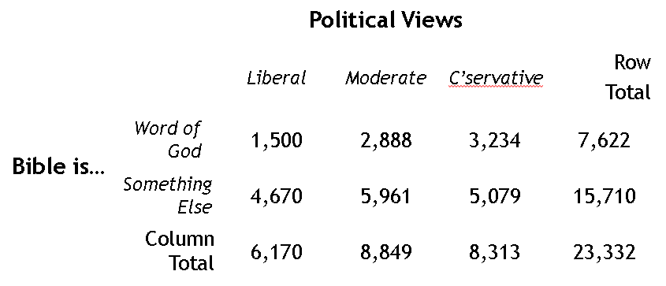

- [From the recorded lecture] Is there are a relationship between X and Y in the population from which the sample data were collected? Use χ² to test the hypothesis of no association (w/ α=0.05). Use RR and OR to describe the association.

- [From the synchronous session] Is there an association between people’s favorite pet and whether they are right or left handed?

