YOUR TA’S NAME:

Lecture Worksheet
Thursday 12/3/2020

MAIN POINTS OF LECTURE

- MAIN TOPIC: Models with k continuous predictor variables (X₁ through X_{k}) and a continuous response variable
  - Sample Prediction Equation:
  - The ordinary least squares (OLS) method is used to estimate a and b₁ through b_{j} … again, this method minimizes the sum of the squared prediction errors
  - The intercept, a, equals the predicted value of Y when each of the k predictor variables (X₁ through X_{j}) equal 0
  - Multiple regression coefficient b_{k} represents the expected change in Y associated with a one unit increase in X_{j}, controlling for all other predictors in the model
  - R² expresses the proportion of variation in Y that is accounted for by the predictor variables taken as a whole
  - We use R²_{Y•X1…Xk} to estimate ρ²_{Y•X1…Xk}; Hypothesis tests about ρ²_{Y•X1…Xk} are F tests with df_{num}=k and df_{denom}= n-k-1. The test statistic is the same as for two variable regression (except for the different numbers of degrees of freedom)
  - We use b_{k} to estimate β_{k}; Hypothesis tests about β_{k} are t tests with n-k-1 degrees of freedom. The test statistic is
- BONUS TOPIC #1: Call the model that contains the full set of X variables the complete model; it has k₂ impendent variables. Call a model that contains a subset of those X variables the reduced model; it contains k₁ independent variables. Question: Does the addition of the k₂-k₁ new predictor variables in the complete model improve our ability to predict Y (relative to the reduced model)? Answer: Test the null hypothesis that the additional variables explain no additional variation in Y. This test is an F test, with df_{num}=k₂-k₂, df_{denom}=n-k₂-1, and
- BONUS TOPIC #2: In a model with a discrete independent variable X that has j categories, X should be represented by a series of j-1 “dummy variables” that indicate whether individuals belong to categories of X. This is directly analogous to ANOVA.
- BONUS TOPIC #3: Interaction terms … a strategy for allowing the effect of X₁ on Y to vary across levels of X₂ and simultaneously allowing the effect of X₂ on Y to vary across levels of X₁ … can be modeling by adding a new variable that equals X₁×X₂
QUESTIONS
From the recorded lecture
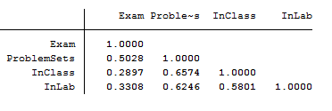
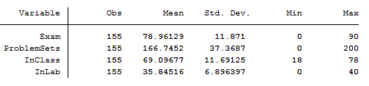

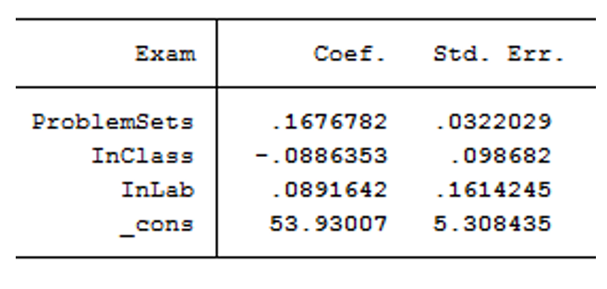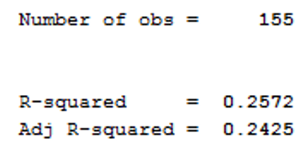

- Interpret the intercept, the slopes, and R²

Intercept: When the value of all the X variables is 0, the predicted value of Y is 53.93007

Slope for ProblemSets: Among people who are the same with respect to the other X variables, a 1 unit increase in Problem Set scores is associated with a 0.167 increase in Exam scores.

Slope for InClass: Among people who are the same with respect to the other X variables, a 1 unit increase in In Class scores is associated with a 0.088 decline in Exam scores.

Slope for InLab: Among people who are the same with respect to the other X variables, a 1 unit increase in In Lab scores is associated with a 0.089 increase in Exam scores.

R²: The three X variables in the model explain 25.72% of the variation in Exam Scores.

- Test the hypothesis that ρ²=0; use α=0.05

R² = 0.2572
The critical value of F with α=0.05, df_{NUM = k} = 3 and df_{DENOM = n-k-1 = 155-3-1} = 151 is 2.70
$$\text{S}{\text{S}}_{\text{REGRESSION}}=(R_{}^{2})(\text{S}{\text{S}}_{\text{TOTAL}})=(\text{0.25}\text{72})(\text{21701.779})=\text{5,581.7}$$
$$\text{S}{\text{S}}_{\text{TOTAL}}=(s_{Y}^{2})(N-1)=({11.871}^{2})(\text{155}-1)=\text{21,701.779}$$
$$\text{S}{\text{S}}_{\text{ERROR}}=\text{S}{\text{S}}_{\text{TOTAL}}-\text{S}{\text{S}}_{\text{REGRESSION}}=\text{21,701.779}-\text{5,581.7 = 16,120}=\text{107,892}$$
$$F_{\text{K}\text{,N}-K-1}=\frac{\text{S}{\text{S}}_{\text{REGRESSION}}\text{/}\text{K}}{\text{S}{\text{S}}_{\text{ERROR}}\text{/N}-K-1}=\frac{\text{5,581.7}\text{/}\text{3}}{\text{16,120}\text{/}\text{151}}=\text{17.4}$$

Thus, we reject H₀ that ρ² = 0. The three X variables do explain some of the variation in Y in the population.

- Test the hypothesis that β_{ProblemSets}=0; use α=0.05

The critical value of t with α=0.05 and N-K-1 = 151 degrees of freedom is 1.984

The value of t is just the coefficient (0.167) divided by the standard error (0.032) from the regression table above. That means t = 0.167/0.032 = 5.219

We thus reject the null hypothesis that the slope for this variable equals 0 in the population

