YOUR TA’S NAME:

Lecture Worksheet
Tuesday 10/1/2020

MAIN POINTS OF LECTURE

- Definitions:
  - A random event is an event in which the outcome is determined by chance (e.g., whether a flipped coin will turn up heads or tails)
  - Probability is an expression of how likely it is that a particular outcome will result from a random event where 0 means it certainly won’t happen and 1 means it certainly will (e.g., 0.5 for heads and 0.5 for tails if you flip a fair coin)
  - A random variable is the numeric outcome of a random event (e.g., how many heads turn up if you flip a fair coin 10 times)

- A continuous random variable is a random variable that can take any numeric value within a range of values
  - For a continuous random variable, the probability density function is a curve that provides information about the probability that Y falls between two values a and b … P(a ≤ Y ≤ b)

- A normal random variable is a type of continuous random variable which is symmetric and can be characterized by its expected value μ_{Y} and standard deviation σ_{Y}
  - For any normally distributed random variable…
…~68% of the area under the curve falls within the range -1Z and +1Z
…~95% of the area under the curve falls within the range -2Z and +2Z
…~99.7% of the area under the curve falls within the range -3Z and +3Z
…100% of the area under the curve falls within the range -∞Z and + ∞Z

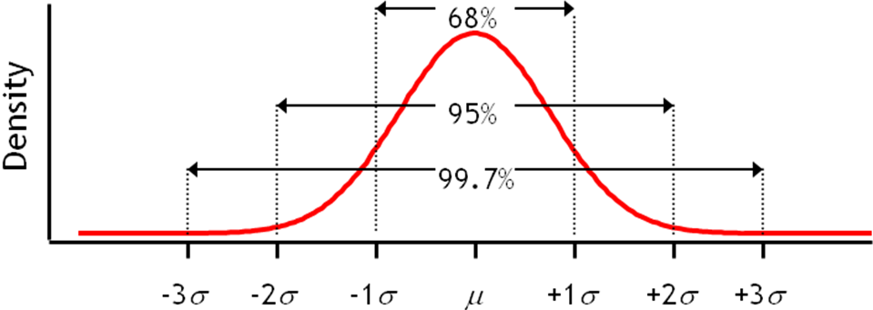

- In general, for two random variables Y and Z:
  - Mean of Y + Z = μY+Z = μY + μZ
  - Mean of Y - Z = μY-Z = μY – μZ
  - Variance of Y + Z = σ²Y+Z = σ²Y + σ²Z
  - Variance of Y - Z = σ²Y-Z = σ²Y + σ²Z
QUESTIONS

- (From the recorded lecture): Men’s height in inches in the United States is normally distributed with μ=70 and σ=2.5

What proportion of men is taller than me (69.5”)?

Z = (69.5-70.0)/2.5 = -0.2
P(Y>69.5”) = P(Z>-0.2) = 0.5793

What proportion of men is between 66” and 71” tall?

Z for 66” = (66-70)/2.5 = -1.6
Z for 71” = (71-70)/2.5 = 0.4
P(66<Y<71) = P(-1.6<Z<0.4) = 0.6554 – 0.0548 = 0.6006

- (From the recorded lecture): The distributions of times for 19-34 year men and women to complete a half marathon are (more or less) normal
Men: μ_{YMEN} (in minutes) is 125 with σ_{YMEN} of 25
Women: μ_{YWOMEN} is 140 with σ_{YWOMEN} of 23

What proportion of women finish half marathons ahead of the average man?

This is the same as asking “what proportion of women finish ahead of 125 minutes?”
Z = (125-140)/23 = -0.65
P(Y<125) = P(Z<-0.65) = 0.2578

- (From the recorded lecture): The distributions of times for 19-34 year men and women to complete a half marathon are (more or less) normal
Men: μ_{YMEN} (in minutes) is 125 with σ_{YMEN} of 25
Women: μ_{YWOMEN} is 140 with σ_{YWOMEN} of 23

What is the distribution of the difference between men’s and women’s race times?

The expected value of the difference is μ_{YMEN} — μ_{YWOMEN} = 125-140 = -15
The variance of the distribution of the difference is σ_{YMEN}²+ σ_{YWOMEN}² = 25² + 23² = 1,154, so σ_{YMEN-YWOMEN} = the square root of 1154 = 33.97
The distribution of the difference between men’s and women’s race time is centered over -15 minutes (that is, with women running 15 minutes slower on average), with a standard deviation of 33.97

- (From the synchronous class session): The mean weight of American adults is a normal random variable Y, with μ=170 pounds and σ=15. The elevator we want to install in our new office building can hold 1,800 pounds.

  - What is the distribution of the total weight of 10 people?

The distribution of weight for each adult has μ=170 pounds and σ=15. This problem asks you to sum the expected values of the 10 people. So, the expected value of the distribution of the sum of the 10 weights is 170 x 10 = 1,700. The variance of the distribution of the sum of the 10 weights is 10 x 15² = 2,250. So, the standard deviation is the square root of 2,250, or 47.4.

  - What is the probability that 10 people selected at random would exceed the elevator’s weight limit?

Given that the distribution of the sum of 10 randomly selected people’s weights is centered over 1,700 and has a standard deviation of 47.4, this question asks about the probability of getting a value for the sum of the 10 weights that is greater than 1,800. For that: Z = (1800-1700)/47.4 = 2.11. What is P(Z>2.11)? 0.0174. That is, there is a 1.74% chance that 10 people selected at random would exceed the weight limit.

