YOUR TA’S NAME:

Lecture Worksheet
Thursday 12/10/2020

MAIN POINTS OF LECTURE

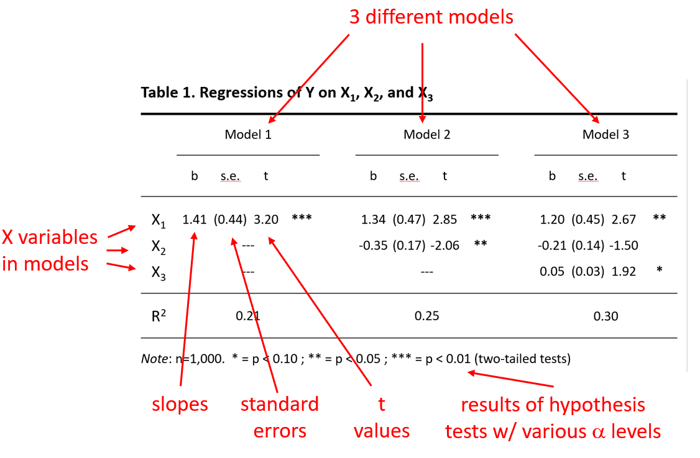
QUESTIONS
From the synchronous session

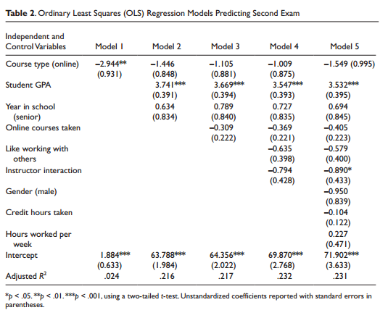

- Interpret the slope in Model 1. That is, without adjusting for anything else, what can you say about the association in the sample between “Course type (online)” and “Second Exam” scores? What can you say about whether there is evidence for a significant association in the population?

- Compare the results of Models 1 and 2. Would you agree with the statement that “Student GPA” confounds the association between “Course type (online)” and “Second Exam” scores? Why or why not?

- Interpret the intercept for Model 2. What does the number 63.788 mean?

