YOUR TA’S NAME:

Lecture Worksheet
Thursday 12/10/2020

MAIN POINTS OF LECTURE

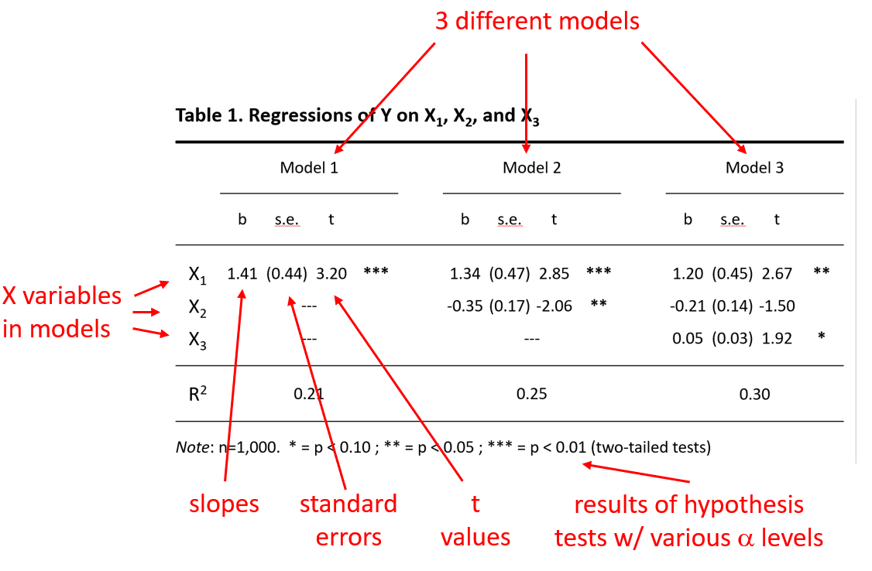
QUESTIONS
From the synchronous session

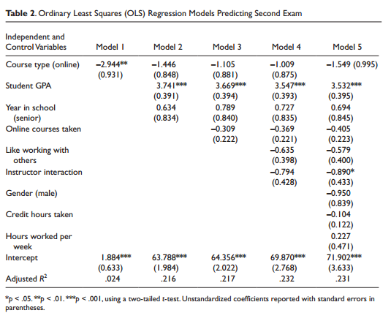

- Interpret the slope in Model 1. That is, without adjusting for anything else, what can you say about the association in the sample between “Course type (online)” and “Second Exam” scores? What can you say about whether there is evidence for a significant association in the population?

The coefficient indicates that the mean second exam score for online courses is 2.944 points lower than for other courses (which presumably is in-person courses). Because there are two asterisks next to the coefficient, we would reject (at the α=0.01 level) the null hypothesis that this slope equals zero in the population.

- Compare the results of Models 1 and 2. Would you agree with the statement that “Student GPA” confounds the association between “Course type (online)” and “Second Exam” scores? Why or why not?

You should agree with the statement.

In Model 1 (which includes no controls for confounders) the coefficient for “Course type (online)” is almost -3 and statistically significant (that is, we’d reject the null hypothesis that it equals zero in the population). After adjusting for GPA in Model 2, the coefficient for “Course type (online)” is about half the size it was in Model 1—but more importantly we would fail to reject the null hypothesis that it equals zero in the population. Apparently, the association between course type and exam score is confounded by GPA.

- Interpret the intercept for Model 2. What does the number 63.788 mean?

Among people who have values of 0 on all the X variables in the model—so, who are NOT seniors, who have a GPA of 0, and who are not taking the course online—the mean second exam score was 63.788.

